# Game Overview:

The team’s proposed game is the creation of a “museum” like environment where they can showcase different elements/requirements of the assessment in the environment. This can be done in either separate rooms or a single larger room. The user of the game will move in the environment, interact with each “showcase” available and notice that different game specifications have been fulfilled in each(E.g. push a button and turn on the lights - Lighting demonstration).

# Task Identification & Allocation:

The team will create a rough class diagram and game flow chart in order to proper showcase the needs of the game. From there the team will highlight which sections each member will cover.

Red=George Alexandru Ciobanita.

Blue=Nedelin Gochev.

# Rough Class Diagrams & Game Flow:

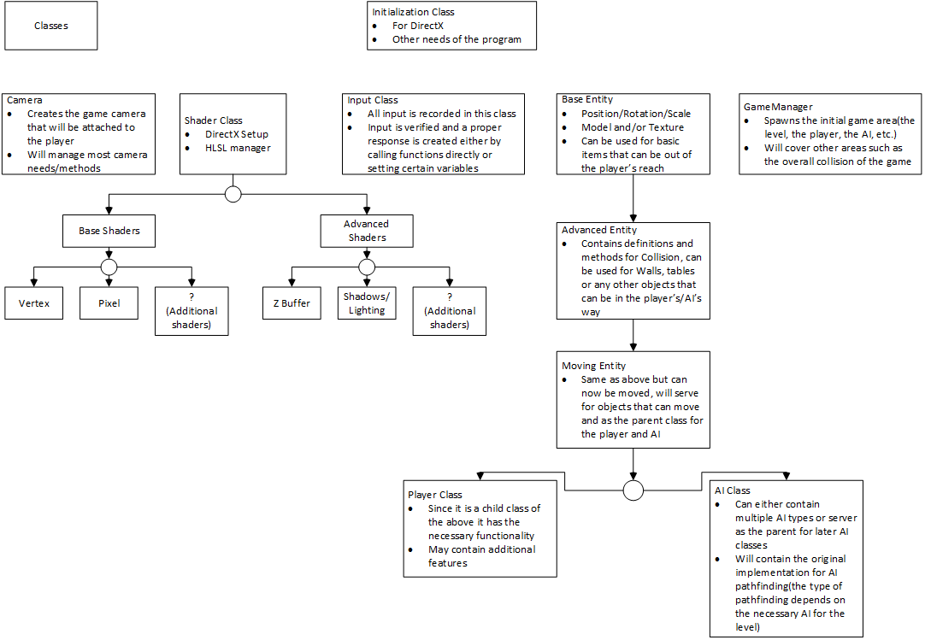

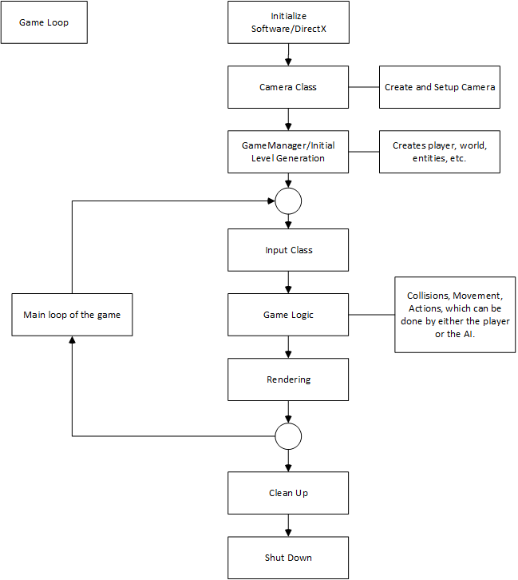There will be final updated version of the above as the team approaches the hand in date. These version will contain updated information from the resources gathered.

# Version Control & Log Keeping/Testing:

The following are proposed for better and safer work conduct:

1. Github, in order to keep files, versions and backup available online.
   1. Team members will upload files and information, with appropriate descriptions and titles, as they acquire it and keep it available in the “AGP-Assignment” repository.
   2. Members can create/update files as they see fit (there is a document available in the repository that each member has to update).
   3. Members will communicate with each other in order to clearly update any current piece of information. There is the possibility that the findings of one member can help the other realise mistakes or improve.
2. Visual Studio can be setup to create logs after the codebase has been compiled and tested.
3. For future use the team can employ the use of “assert” a function mainly used for testing. This can work well with the Visual Studio log implementation as the following are logged: the function expression, name of source file, and the line number where it happened (e.g. Assertion failed: *expression*, file *filename*, *line number*).
4. Grey-box testing, a combination between White & Black box testing, can be used through implementation.